MACH4METAL

metalworking machinery
Transito 21
6909 DA BABBERICH Netherlands
Tel. +31 (0)316-247123
Fax: +31 (0)316-247956
info@mach4metal.com
www.mach4metal.com

Bank No : 66.52.13.883
IBAN : NL33 INGB 0665 2138 83
BIC : INGBNL2A

FACCIN 4HEL 3.000 x 120 mm
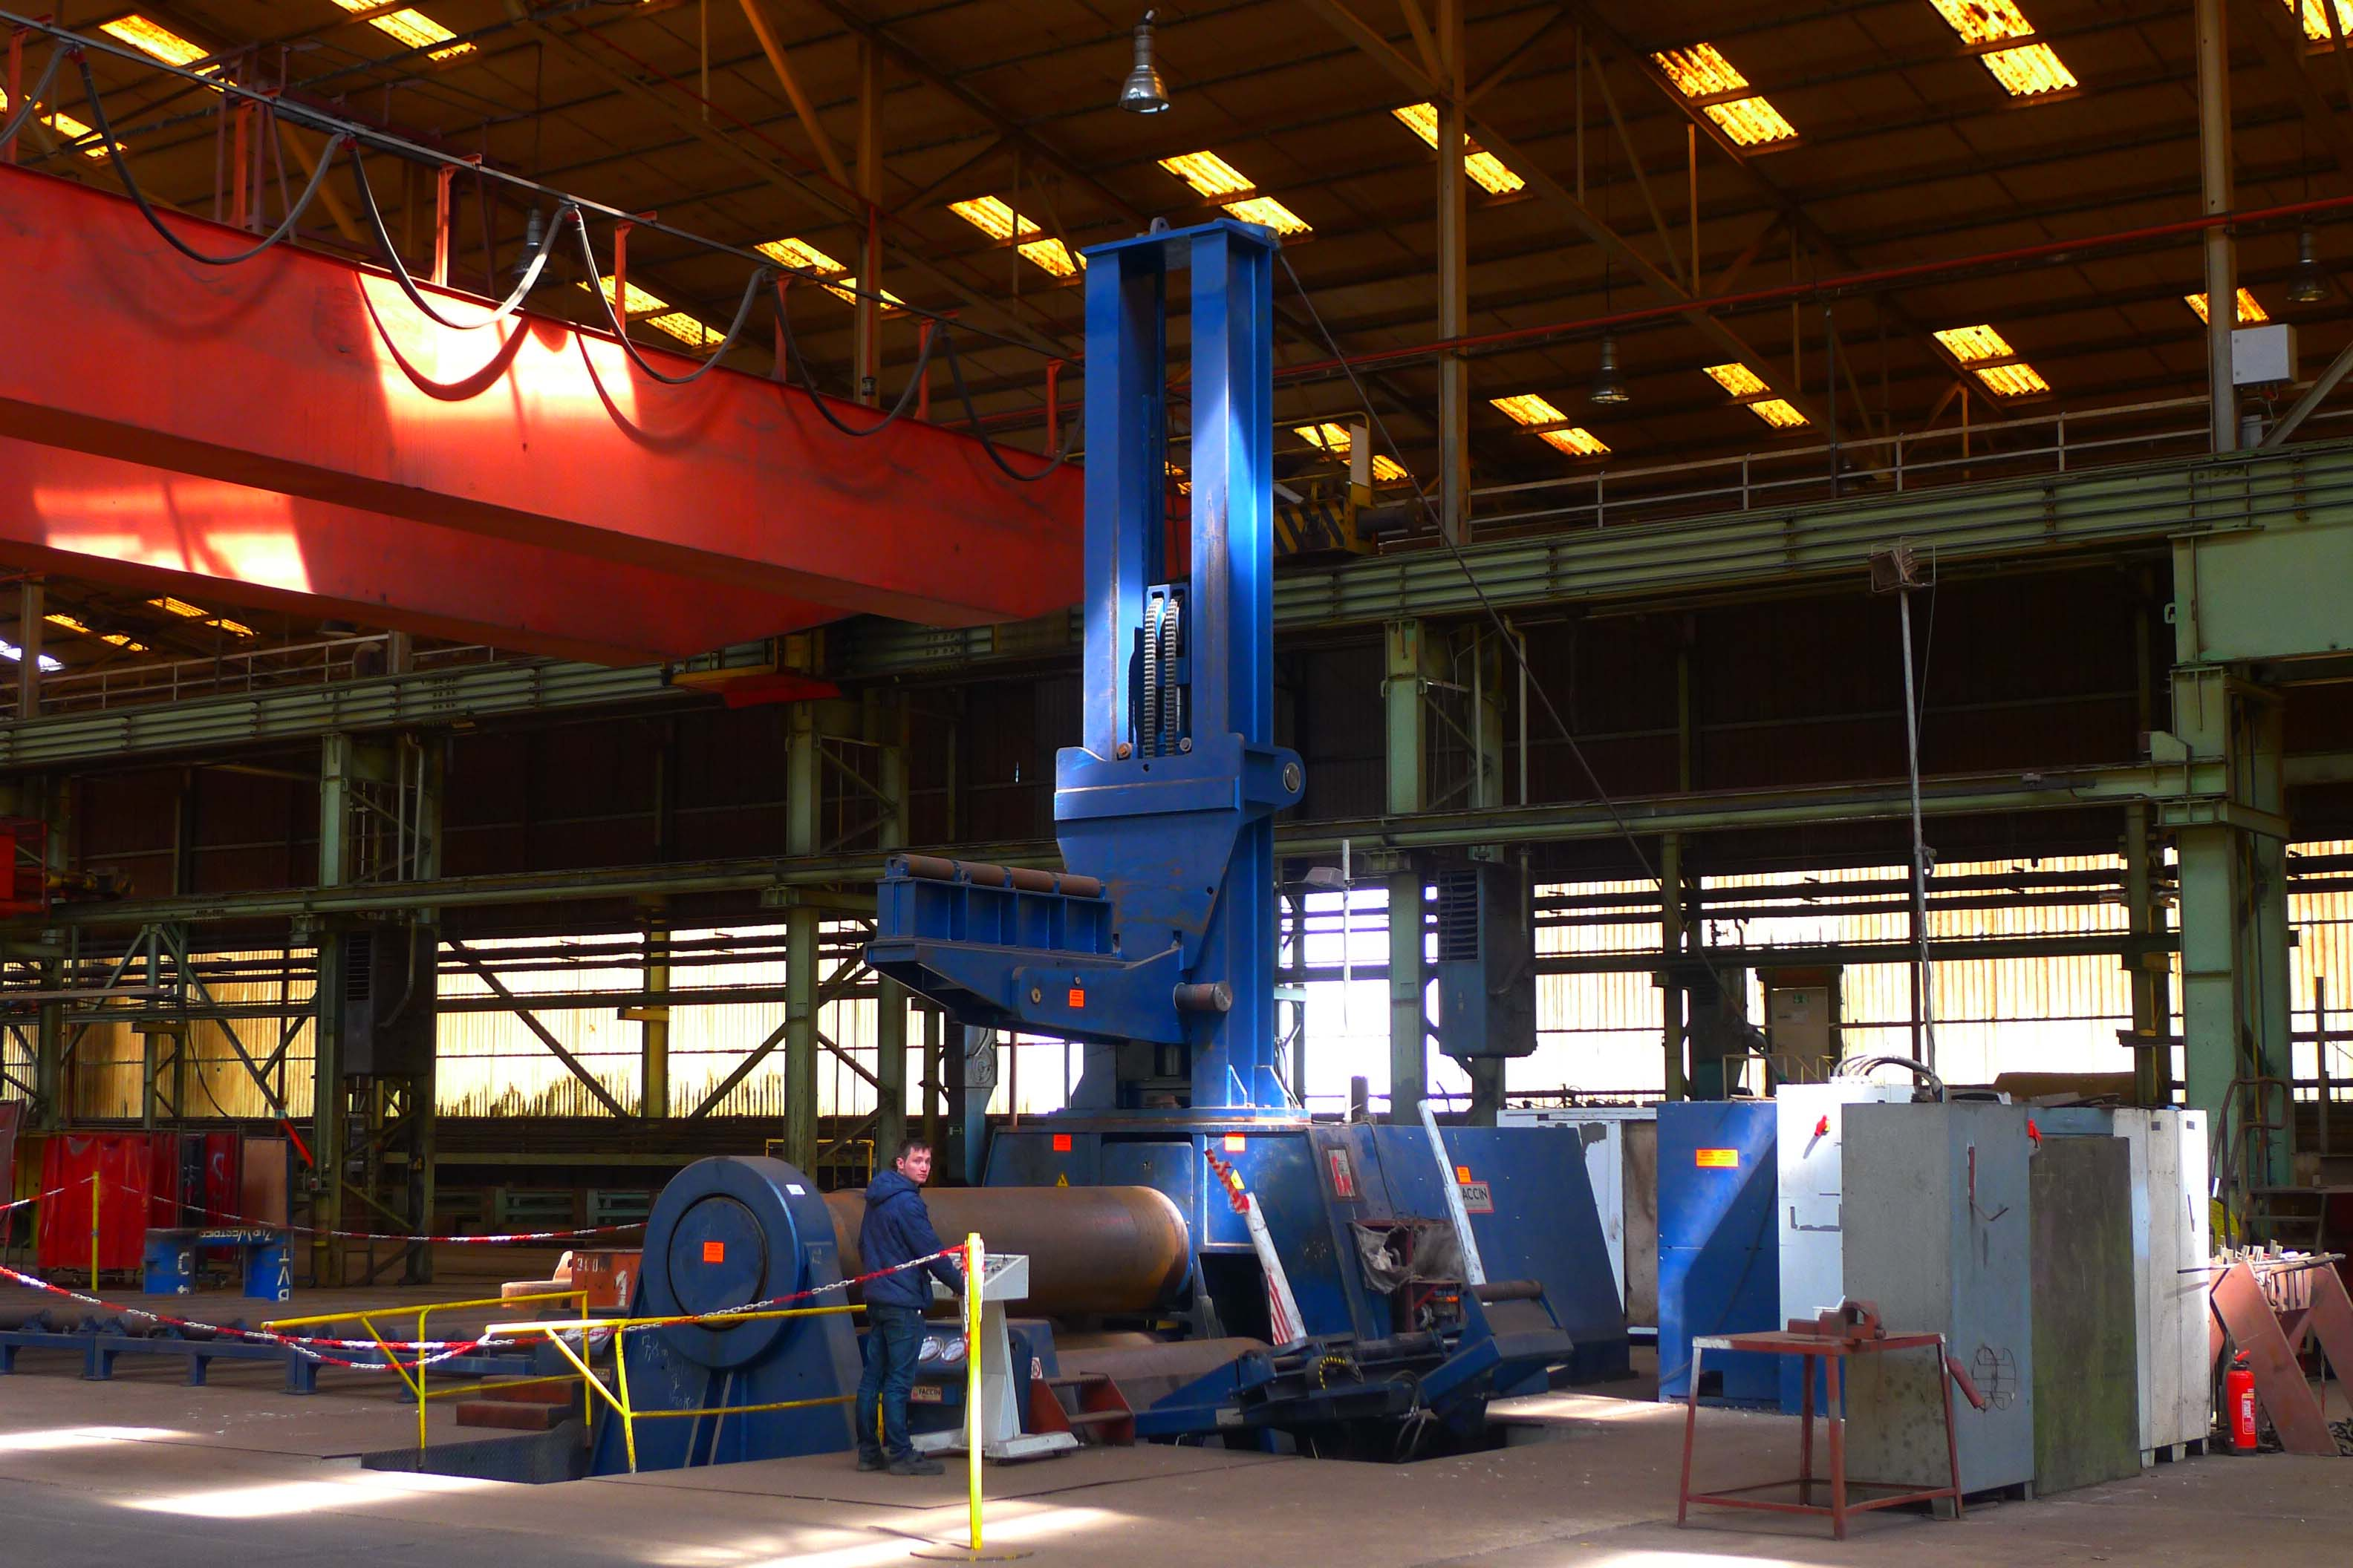

- Make : FACCIN - Italia
- Typ : 4 HEL / S 3186
- Serial . No :
- Age : 2011

- bending length : 3050 mm
Bending capacity 260 N/mm²
- Ø 4300 : 3000 x 115
- Ø 1120 : 3000 x 100
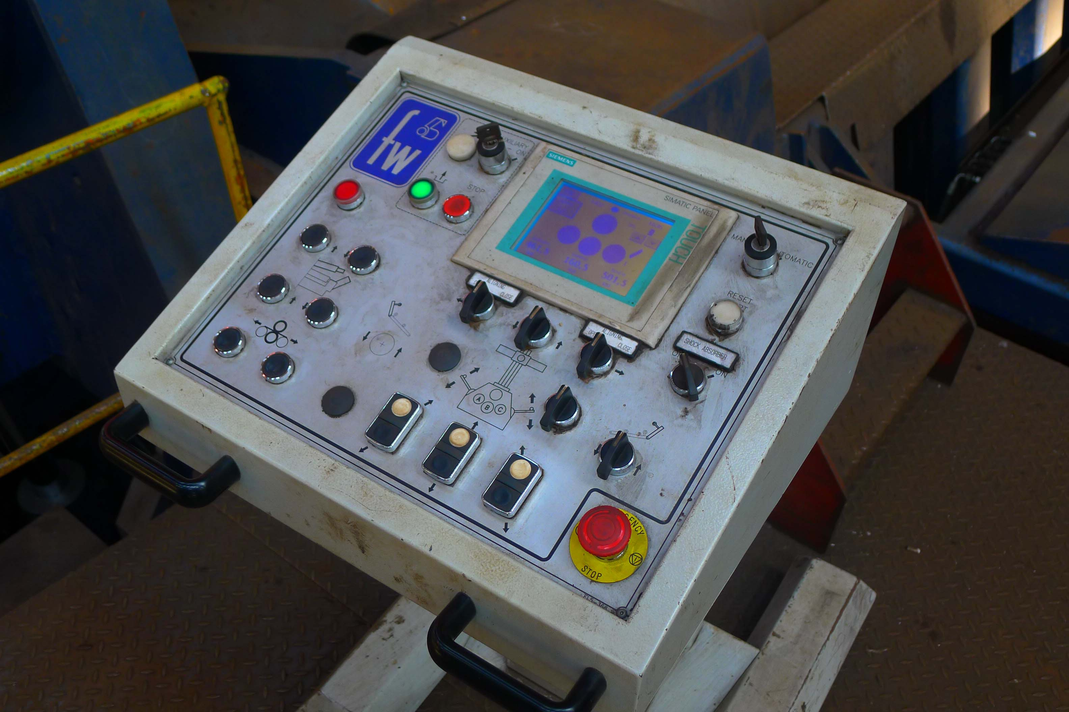
Pre Bending capacity 260 N/mm²
- Ø 4300 : 3000 x 100
- Ø 1120 : 3000 x 90

- Top roll Ø : 860
- Lower roll Ø : 820
- Side roll Ø : 720
- Power Ps : 225
- Pressure upper roll : 1.900 Ton
- Working speed : Vario 2 – 4 M/min
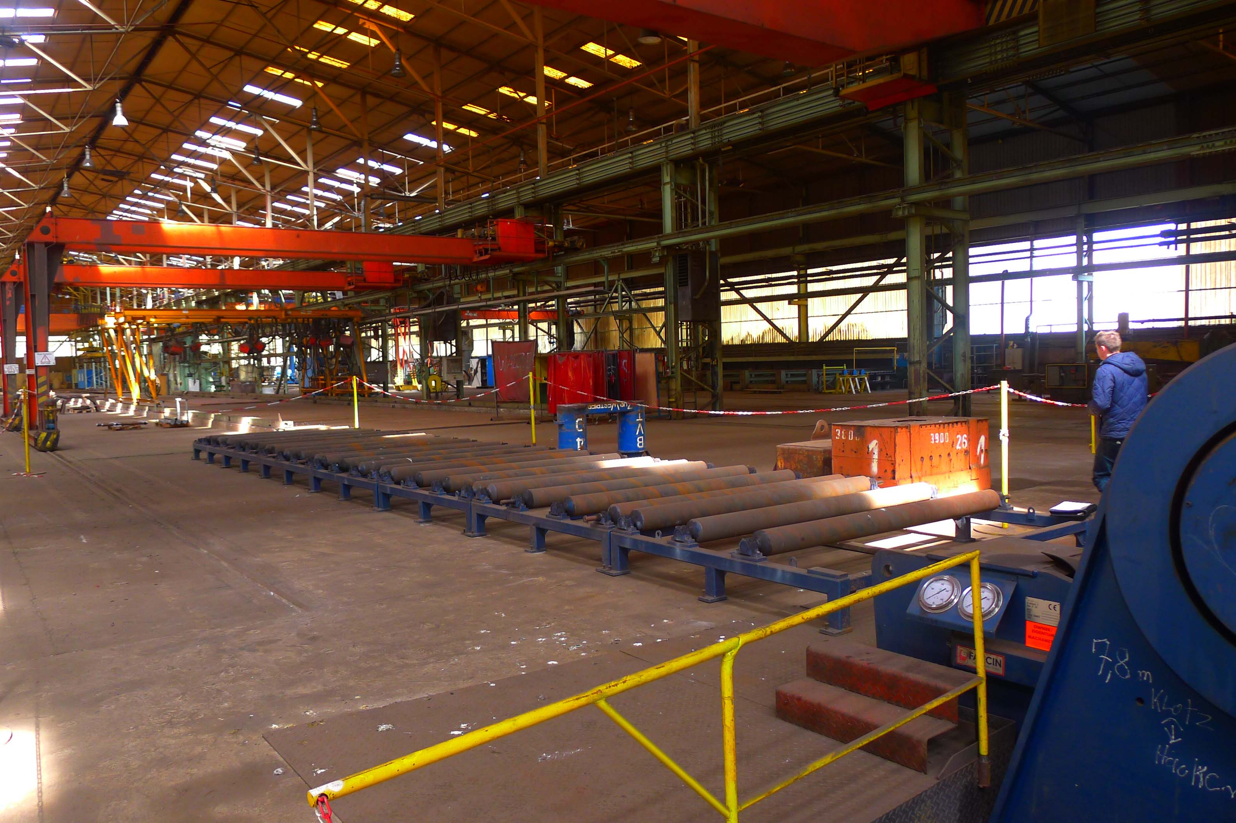
- Top support Ø 5.000 x 8 T
- Side support Ø 5.000 x 5 T
- Conical bending attachment
- Hardened rolls

- Length : 10.000
- Width : 4.400
- Height : 4.000
- Weight 160.000 Kg
- Under power in Europe
- Roller track 18.000 x 3.000 up to 90 mm

Please Note: The above information has been obtained to the best of our ability and belief from, and from the manufacturers where possible. It is given in good faith, but its accuracy can not be guaranteed. Accordingly, it will not form a representation or constitute contractual terms. We advise you to check any vital details!

